TEMPLATE INSTRUCTIONS
This template document contains guidance notes, such as this one. These instructions should therefore be deleted before the release of the document. This also applies to this chapter "Template instructions". Information highlighted in yellow should also be evaluated and completed.
Sections that are indicated as optional can be deleted. Also, required content can be added.
The version history below applies to the template and not to the resulting document. Clean up the table as needed and use it for your document control purposes.
Template Version History
Version | Date of validity | Author | Description of change
1 | 2022-04-04 | Célia Cruz | First version
2 | 2022-06-29 | Célia Cruz | Review formatting. Clarify requirements traceability

Version History
Version | Date of validity | Created by | Approved by | Description of change
1 | YYYY-MM-DD | [Name, including digital signature] | [Name, including digital signature] | First version

Purpose
This document describes the requirements specification for a software system.
The purpose is to be an input for the developer team to understand what needs to be done technically. This document should also provide information for the software testers to develop test specifications.

Responsibilities
Please adapt the responsibilities accordingly to the company.
This document was created by the CTO / Head of Software Development / Software Development Project Manager. It is their responsibility and of software developers to further develop and complete this document.

Context

Product / Software
Name of the product | Version of the product | Software version of the product | Basic UDI-DI (optional)
< name of the product> | <version of the product. If standalone software, use either this or the next column and delete the other> | <version of the software> | <Basic UDI-DI, if/when available>

Requirements
Please add the context diagram (e.g., UML component diagram), where the interfaces are recognizable from an external point of view. The following diagram serves as an example and must be adapted.

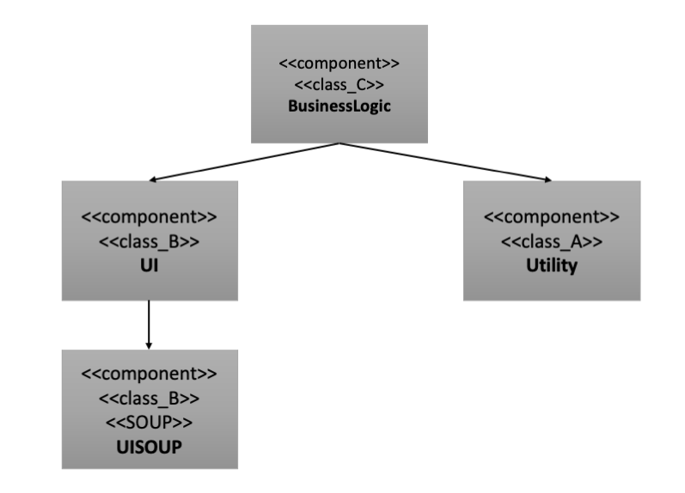

Overview and System Limits
The software architecture where the description of such information is documented on TMP-SW-05 Software Architecture.
If the software is integrated into a specific system, describe briefly the system and add specific requirements for the integration of your software in this system.

Runtime environment

Hardware
Provide a list of products (hardware) that are going to be supported. The list can define concrete products, (e.g., iPhone 13 Pro Max) or specify the minimum characteristics such as processor, RAM, disk space, and screen size and resolution. If necessary, also include the maximum resources that can be consumed.

Requirement ID | SRS-RUNTIMEHD-001
Title | Minimum Requirements
Description | The software must run on a PC with the hardware configuration of a 2 GHz CPU, 2GB RAM, 1GB free hard disk space, and a screen resolution of 1024 x 768, 256 colors.

Requirement ID | SRS-RUNTIMEHD-002
Title | RAM during Runtime
Description | The software may not occupy more than 2GB RAM during runtime.

Requirement ID | SRS-RUNTIMEHD-003
Title | Hard disk during Runtime
Description | The software may not occupy more than 1.0GB hard disk space for installation and not more than 50 GB hard disk for up to 1000 patients.

Operating System
Describe the operating system including version and/or service patch. Also include time zone, language, character sets, or countries.

Requirement ID | SRS-RUNTIMEOS-001
Title | Operating System
Description

Runtime Environment
Describe the runtime environment. Include Run-times (.NET, JRE, Browser incl. Versions) and Plugins (including manufactures that are not part of the product).

Requirement ID | SRS-RUNTIMEENV-001
Title
Description

Other Software Applications
If required, describe other software applications including version and manufacturers, which may run in parallel as firewalls, email client, etc., pertinent for the product.

Requirement ID | SRS-RUNTIMEOTHERS-001
Title
Description

Functionalities and Performance
This is the core of your Software Requirements Specifications. It contains the purpose of the software expressed in technical requirements. You may organize this part into sub-sections.

Requirement ID | SRS-XXX-001
Title | Sample requirement about a function
Description | The software shall compute the zzz parameters with the a, b, c, and d input parameter, with the use of the XXX algorithm.

Requirement ID | SRS-XXX-002
Title | Sample requirement about a function
Description | The software shall save the result of computations in xyz format.

Safety, security, and privacy protection
This section is about software features like confidentiality, integrity control, reliability, and availability. Examples include encryption of communication, authentication of neighboring devices / neighboring systems / communication partners, updating authentication information, and authorization (Who may call which function?).
See also 2016/679 GDPR in Europe, especially articles 15 to 22. For the USA, see also HIPAA requirements.
You can add subsections on confidentiality, security, integrity, virus, malware protection, and operational security.

Requirement ID | SRS-XXX-001
Title | Patient data
Description | The software stores patient data with a checksum to ensure their integrity.

Requirement ID | SRS-XXX-002
Title | Password protected functions
Description | The following functions are protected by password:  - Configuration  - Firmware update

Requirement ID | SRS-XXX-003
Title | Antivirus – antimalware
Description | The software shall run with an antivirus / antimalware present on the target PC.

Requirement ID | SRS-XXX-004
Title | Right to forget
Description | The software has a function to delete all patient data. The deletion is permanent and not reversible

Graphical User Interface (GUI)
The requirements here may have traceability with the results from the implementation of IEC 62366.

Performance
Define the default response time, which can be overwritten for individual screens or functions.

Requirement ID | SRS-GUIPERF-001
Title
Description

Layout, Guidelines
Reference UI style guides (e.g., the style guide from Apple) and standards (e.g., ISO 9241 family) to globally define UI (design) requirements.
The intended purpose must be taken into consideration. These specifications can also be understood in the context of the usability specification.

Requirement ID | SRS-GUILAYOUT-001
Title
Description

Other
Address here other possible issues that affect the UI, such as multilingualism, Online help, Usability exclusively via keyboard, General UI settings (such as font size, colors, etc.), among others.

Requirement ID | SRS-GUIOTHER-001
Title
Description

Screens

Screen Flow
If the application is screen-based, use an activity diagram to provide an overview of the flow logic of the screen masks. The flow below is an example. Please adapt to the situation.
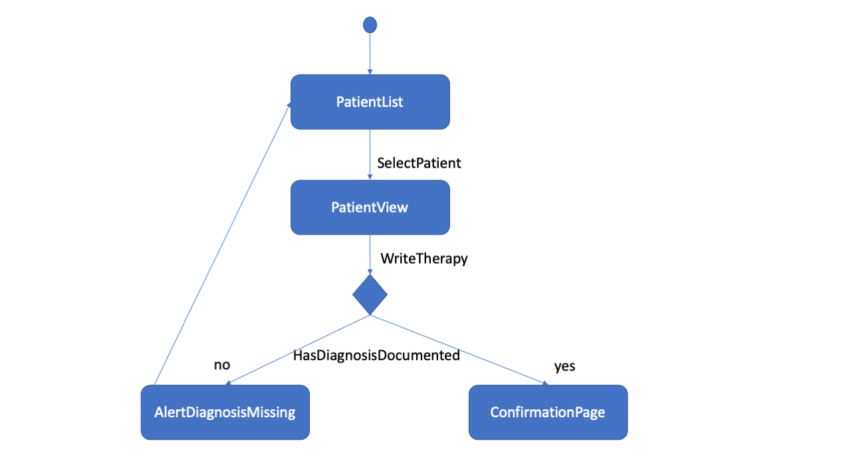

General Screen Layout
If there is a master layout (e.g., with a menu or navigation bar), describe it here. It can include a mock-up screen or wireframe. Do not only describe the static layout but also dynamic behavior i.e., reaction of system to actions of users.

Requirement ID | SRS-XXX-001
Title | Menu items and other widgets
Description | The software has the following items:  - Menu file ...  - Widgets in the main window (slider, button, radiobutton, textfield).

Screens
Provide a short overview with a mockup screen and describe the requirements for the needed layouts/behaviors necessary.
You can also/alternatively describe the screen in more detail, for each element, indicating the static layout and dynamic behavior (when clicking on something, e.g.), the type of data, accepted values, and other restrictions.
You can have different subchapters, as applicable.
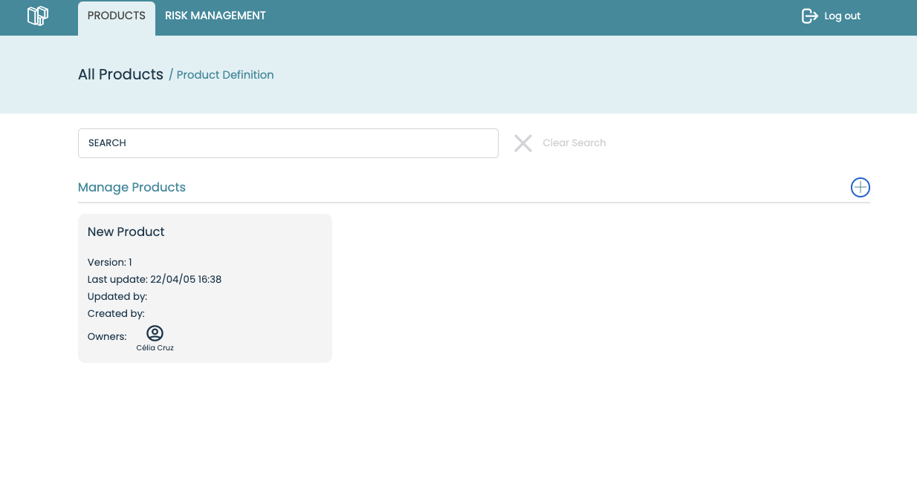

Requirement ID | SRS-SCREEN-001
Title | List of patients
Description | The system displays the list of all patients [each with name, date, and patient ID].

Requirement ID | SRS-SCREEN-002
Title | List of patients
Description | The system displays a form in which the patient master data can be entered: first name, last name, date of birth [in a format that adapts to the country settings], gender [male, female, other/unknown], insurance number]. After saving or canceling, you will be taken to Screen02.

User maintenance
Requirement ID | SRS-XXX-001
Title | Application logs
Description | Generate a log file containing:  - The state of the application and the steps performed to reach that state,  - The possible error logs, if any.

Regulatory requirements
Describe legal requirements, which may include data protection or data security. These legal requirements may already be described by other system requirements, for example by the fact that users must identify themselves with the username and password (of a certain quality) in the system.

Requirement ID | SRS-XXX-001
Title | About XXX
Description | XXX shall display an “About” window. This window displays the current version of the application.

Requirement ID | SRS-XXX-002
Title | CE Mark
Description | The software shall display the CE Mark in the “About…” window.  [For devices that require Notified Body] The CE Mark is displayed with the 4-digits number of the Notified Body.

Other

Database
This section is only applicable if the software is connected to an external database. The specification of these interface types shall include type, name, and version of DBMS, database scheme.

Interfaces Import/Export
Export/import shall not be an independent interface but be realized by one of the given interfaces.

Other interfaces
Describe the hardware and software interfaces of the software in the system.
For PEMS/Electro-medical Devices, add requirements about the integration of software and hardware.
Also, add here communication and network details, like IP, wireless, Bluetooth …
If the software is in interface with other software, describe here the requirements for data exchanges.
Describe whether/how users can register or activate the software. This, however, should be part of the UI specification.

Personnel and training
Requirements about the capabilities/knowledge of users, the training they shall have before using software
Requirement ID | SRS-XXX-USR-001
Title | E-learning
Description | The software is delivered with an e-learning module.

Packaging and installation
Requirement ID | SRS-XXX-PAK-001
Title | Packaging
Description | The device shall be delivered on yxz media.

Requirement ID | SRS-XXX-PAK-001
Title | Install-shield
Description | The device shall be installed with the use of an install shield.

Verification Methods
Remove this section if you don’t want to have verification methods attached to your requirements.

The verification methods of the requirements are defined below:
- Inspection (I) - control or visual verification:
  - Control of the physical implementation or the installation of a component. The control verifies that the implementation or the installation of a component is compliant with the requirements of diagrams.
  - Control of the documentation describing a component. The control verifies that the documentation is compliant with the requirements.
- Analysis (A) - verification based upon analytical evidences:
  - Verification of functionality, performance, or technical solution of a component by analyzing the data collected by tests in real conditions, by simulation of real conditions, or by an analysis report.
  - Analysis of test data or of design data is used as appropriate to verify requirements.
  - The verification is based upon analytical evidence obtained by calculations, like modeling, simulation, and forecasting.
  - Analysis is used when an acceptable level of confidence cannot be established by other methods or if the analysis is the most cost-effective solution.
- Demonstration (D) - verification of operational characteristics, without quantitative measurement:
  - Verifying a requirement by demonstration implies that the required functionality specified by a requirement is complete.
  - Demonstration is used when a quantitative measurement is not required for verification of the requirements
  - Demonstration includes the control of the technical solutions specified by the non-functional requirements.
- Test (T) - verification of quantitative characteristics with quantitative measurement:
  - Verifying functionality, performance, or technical solution of a component by executing testing scenarios in predefined, controlled, and traceable testing conditions.
  - Tests require the use of special equipment, instrumentation, simulation techniques, or the application of established principles and procedures,
  - Data produced during tests is used to evaluate quantitative results and compare them with requirements.

Requirement ID | Requirement Title | Method
REQ-001 | Verify that the speed is displayed in rpm | D
REQ-001 | Verify that the color of background is blue | I

Examples of tests methods:
Inspection:
Verify that the color of background is blue,
Verify that the user manual has the CE mark on its cover
Verify that the PC has 4Gb memory
Verify that firmware version on electronic card is 1.0.1

Demonstration
Verify that when the user closes the window, a confirmation message appears
Verify that the file is saved in the output directory
Verify that the result is shown
Verify that if a value is out of range, a warning is displayed

Analysis:
Verify that the statistical distribution of results of xxx algorithm is a Gaussian with mean=x and stdev=y, when input data are blah blah
Verify that the linear regression of results of xxx algorithm is a line which value is 1 on the y-axis, at zero on the x-axis,

Test:
Verify that a file of 1Gb is processed in less than 3s
Verify that the response time of the server is 15ms with 20 simultaneous requests

Rule of thumb for software, 80% of requirements are verified by demonstration, 15% by inspection and 5% by analysis or test methods.

Requirements traceability
Add a table with traceability of software requirements of this document with stakeholder or system requirements. If this information is in a systematized system (e.g. JIRA), make sure the connection is made.

Requirement ID | Requirement Title | Stakeholder Requirement | Stakeholder Requirement Title
SRS-REQ-001 | Reading ECG values | FUN-REQ-00A | ECG post-treatment
SRS-REQ-002 | Writing results | FUN-REQ-00A | ECG post-treatment

Annex

Literature
If a reference is made to literature in the document, a bibliography is listed here. Otherwise, delete.

Applicable and relevant Documents
Document Identification | Document Title
TMP-RM-01 | Risk Management File
FRW-SW-01 | Checklist Software Requirements Specifications
SOP-SW-01 | Procedure Software Development
TMP-SW-02 | Software Development Plan
TMP-SW-05 | Software Architecture
FRW-SW-09 | Software Safety Classification

